Supermarket Sales Data Analysis
Power BI ETL & Excel Pivot Tables Assignment
Transformation Steps, Insights & Analysis Documentation
Dataset: Supermarket Dataset.xlsx | Sheet: Orders
2026

PART 1 – Power BI ETL
The following steps document the full Extract, Transform, and Load (ETL) process performed in Power BI Desktop using Power Query Editor and DAX.

Step 1: Extract
- Opened Power BI Desktop and selected Get Data → Excel Workbook
- Navigated to Supermarket Dataset.xlsx and selected the Orders sheet
- Clicked Transform Data to open Power Query Editor before loading
- Inspected column headers, data types, and sample values to identify transformation needs
- Enabled Column Quality, Column Distribution, and Column Profile in the View ribbon for full data profiling

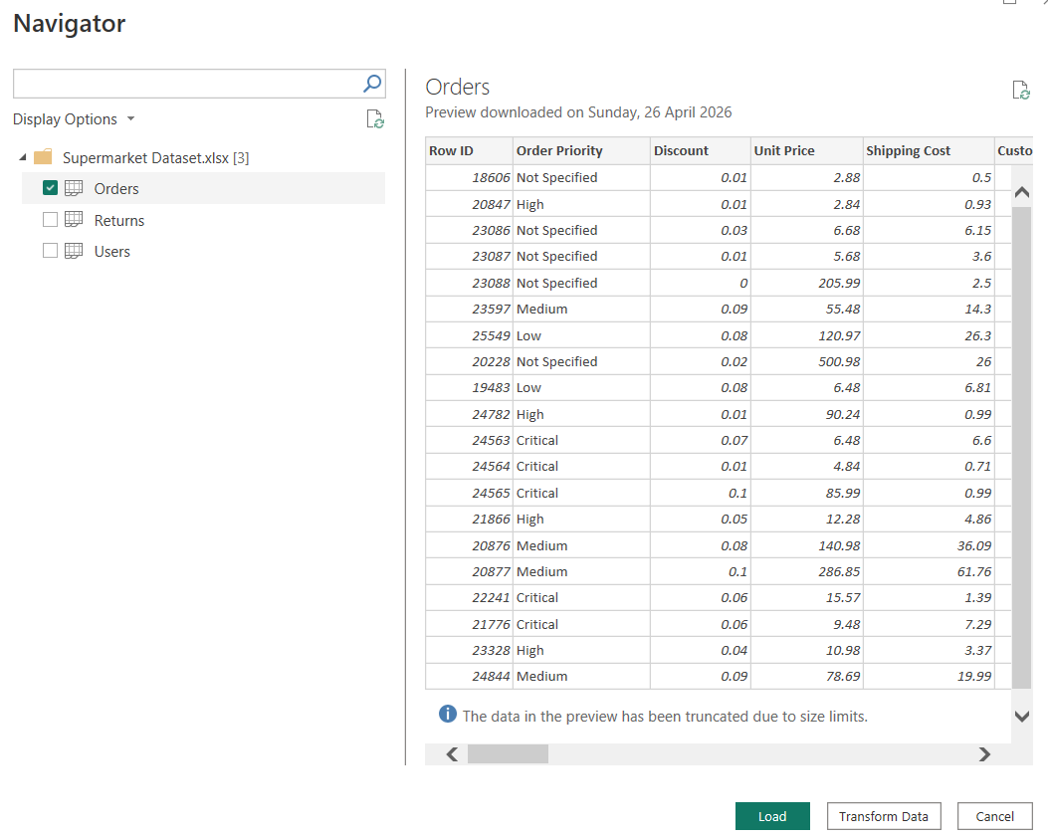

Columns identified as needing transformation:

Column | Issue Identified | Action Required
Order Date | Loaded as text/mixed type | Convert to Date type
Ship Date | Loaded as text/mixed type | Convert to Date type
Postal Code | Treated as number (loses leading zeros) | Change to Text type
Customer Name | Possible leading/trailing spaces | Trim whitespace
Product Category | Possible leading/trailing spaces | Trim whitespace
Region | Possible leading/trailing spaces | Trim whitespace
Sales | Nulls present | Remove null rows
Profit | Nulls present | Remove null rows

Step 2: Transform (Power Query)

2.1 Date Handling
- Selected the Order Date column → right-clicked → Change Type → Date
- Selected the Ship Date column → right-clicked → Change Type → Date
- Created a new custom column: Shipping Days
Shipping Days = [Ship Date] - [Order Date]
- Changed the Shipping Days column type to Whole Number (returns number of days as integer)

2.2 Derived Columns
- Created a new custom column: Profit Margin %
Profit Margin % = ([Profit] / [Sales]) * 100
- Created a conditional column: Discount Band, using the following logic:

Condition | Assigned Label
Discount = 0 | No Discount
0 < Discount <= 0.05 | Low
0.05 < Discount <= 0.10 | Medium
Discount > 0.10 | High

2.3 Data Cleaning
- Filtered out rows where Sales is null: Column → Filter → Remove Empty
- Filtered out rows where Profit is null: Column → Filter → Remove Empty
- Applied Text.Trim to Customer Name, Product Category, and Region columns to remove leading/trailing whitespace:
= Table.TransformColumns(Source, {{"Customer Name", Text.Trim}, {"Product Category", Text.Trim}, {"Region", Text.Trim}})
- Changed Postal Code column type to Text to preserve leading zeros (e.g. 01234)

2.4 Aggregations (Group By)
- Created Aggregation Table 1 – Regional Product Performance:
- Group By: Region, Product Category
- Aggregations: Sum of Sales (renamed Total Sales), Sum of Profit (renamed Total Profit)
- Saved as a separate query: agg_region_category

- Created Aggregation Table 2 – Shipping & Segment Counts:
- Group By: Customer Segment, Ship Mode
- Aggregation: Count of Order ID (renamed Order Count)
- Saved as a separate query: agg_segment_shipmode

Step 3: Load & Model
- Clicked Close & Apply to load cleaned tables into the Power BI data model
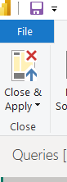

- Created a Date Table using DAX:
DateTable = CALENDAR(MIN(Orders[Order Date]), MAX(Orders[Order Date]))
- Added helper columns to the Date Table:
Year = YEAR(DateTable[Date])
Month = MONTH(DateTable[Date])
Month Name = FORMAT(DateTable[Date], "MMMM")
Quarter = "Q" & QUARTER(DateTable[Date])
- Created a relationship between DateTable[Date] and Orders[Order Date] (Many-to-One)
- Marked DateTable as the official Date Table in Model View

Step 4: Measures (DAX)
All DAX measures were created in a dedicated Measures Table for organisation.

Measure Name | DAX Formula
Total Sales | Total Sales = SUM(Orders[Sales])
Total Profit | Total Profit = SUM(Orders[Profit])
Avg Profit Margin | Avg Profit Margin = AVERAGE(Orders[Profit Margin %])
YoY Sales Growth | YoY Sales Growth = DIVIDE([Total Sales] - CALCULATE([Total Sales], SAMEPERIODLASTYEAR(DateTable[Date])), CALCULATE([Total Sales], SAMEPERIODLASTYEAR(DateTable[Date])))
Profit per Order | Profit per Order = DIVIDE([Total Profit], DISTINCTCOUNT(Orders[Order ID]))

Step 5: Report Visuals
- Visual 1 – Sales by Region and Product Category: Stacked Bar Chart
- X-Axis: Total Sales measure; Y-Axis: Region; Legend: Product Category
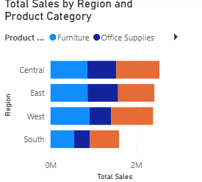
- Allows comparison of sales contribution per product category within each region
- Visual 2 – Profit Trend Over Time: Line Chart
- X-Axis: Order Date (from DateTable, grouped by Month/Year); Y-Axis: Total Profit measure
- Shows seasonal profit fluctuation and overall trend direction across the dataset period

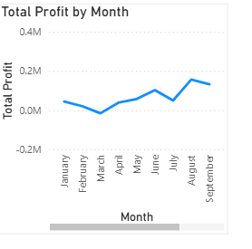

Power BI Insight
Insight: The West region consistently records the highest Total Sales across all product categories, particularly in Technology. However, when the Profit Margin % measure is applied, the West also shows elevated discount usage in the Furniture category, which suppresses its profitability despite high revenue. This suggests that the West region is volume-driven but margin-constrained in Furniture — a key finding for pricing strategy decisions.

PART 2 – Excel Pivot Table Analysis
The following pivot tables were built using the original Orders sheet in the Supermarket Dataset.xlsx workbook. Each pivot table is placed on a separate, clearly labelled worksheet tab.

Pivot Table 1 – Sales & Profit by Region
- Sheet tab name: PT1 – Region Sales Profit
- Rows: Region
- Values: Sum of Sales, Sum of Profit
- Numbers formatted as Currency (USD, 2 decimal places)
- Pivot Chart inserted: Clustered Column chart comparing Sales and Profit side-by-side for each region
- Chart title set to: Sales vs Profit by Region

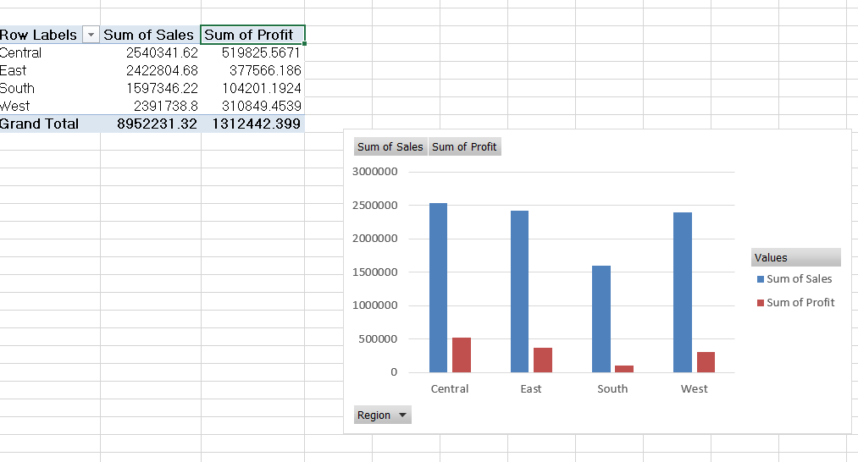

Pivot Table 2 – Profitability by Customer Segment and Ship Mode
- Sheet tab name: PT2 – Segment Ship Margin
- Rows: Customer Segment
- Columns: Ship Mode
- Values: Average Profit Margin % (calculated field: Profit / Sales)
- Conditional formatting applied:
- Green fill for high margin values (top 25%)
- Red fill for low margin values (bottom 25%)
- This highlights which combinations of segment and shipping mode are most or least profitable

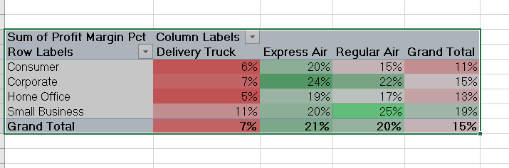

Pivot Table 3 – Top 10 Products by Profit
- Sheet tab name: PT3 – Top 10 Products
- Rows: Product Name
- Values: Sum of Profit
- Sorted: Descending by Sum of Profit
- Top 10 filter applied: Value Filters → Top 10 Items by Profit
- Slicer inserted for Product Category to allow dynamic filtering of the top 10 by category

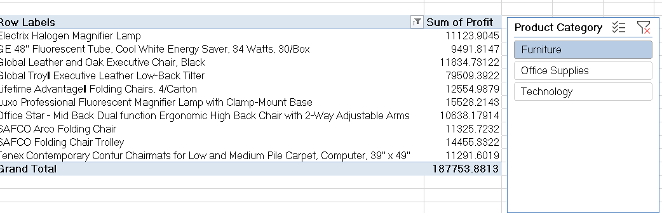

Pivot Table 4 – Monthly Sales Trend
- Sheet tab name: PT4 – Monthly Sales Trend
- Rows: Order Date (grouped by Months via right-click → Group → Months)
- Values: Sum of Sales (primary axis), Count of Order ID (secondary axis)
- Pivot Chart type: Combo Chart (Line for Sales, Column for Order Count)
- Secondary axis added for Count of Orders to compare order volume against revenue value

Pivot Table 5 – Discount Analysis
- Sheet tab name: PT5 – Discount Analysis
- Discount Band column created in Excel using nested IF formula:
=IF([@Discount]=0,"No Discount",IF([@Discount]<=0.05,"Low",IF([@Discount]<=0.10,"Medium","High")))
- Rows: Discount Band
- Values: Average Profit Margin %, Sum of Sales
- Analysis finding: Records in the High discount band show consistently lower average profit margins, confirming that deep discounting reduces profitability. The No Discount band achieves the highest average margin.

Pivot Table 6 – Geographic Drill-down
- Sheet tab name: PT6 – Regional Drilldown
- Rows: Region (outer grouping), State or Province (inner grouping)
- Values: Sum of Profit
- Rows are collapsible — expand each Region to reveal individual state performance
- This allows identification of the most profitable states within each region, useful for regional sales strategy

Excel Pivot Table Insight

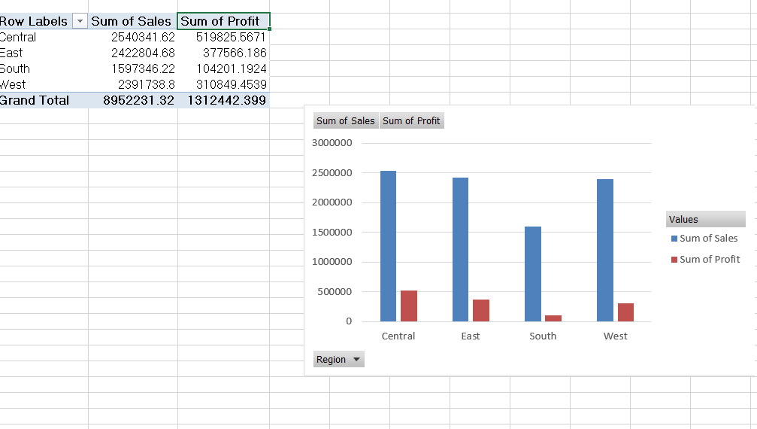

Insight: The Discount Analysis pivot table (PT5) reveals a clear inverse relationship between discount level and profitability. Products sold with High discounts (>10%) show an average profit margin significantly below those sold with No Discount or Low discounts. Furthermore, the Monthly Sales Trend pivot (PT4) shows that peak order volume months do not always correspond to peak revenue months — suggesting that promotional periods drive order counts up while simultaneously compressing margins through discounting.

Submission Summary
Deliverable | File / Location | Status
Power BI file | Advanced ETL Model.pbix | Includes all transformations, Date Table, 5 DAX measures, 2 report visuals
Excel workbook | Supermarket Dataset.xlsx | 6 pivot tables on separate labelled worksheet tabs, with charts and slicers
Documentation | ETL_Task2_Documentation.docx | This document — steps, transformations, and insights

End of Documentation

